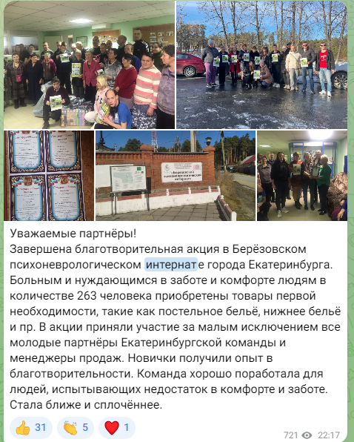

<https://t.me/PRL_PEGASUS/2327>

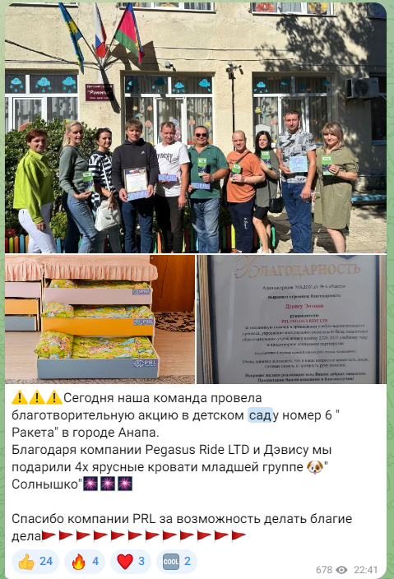

<https://t.me/PRL_PEGASUS/2164>

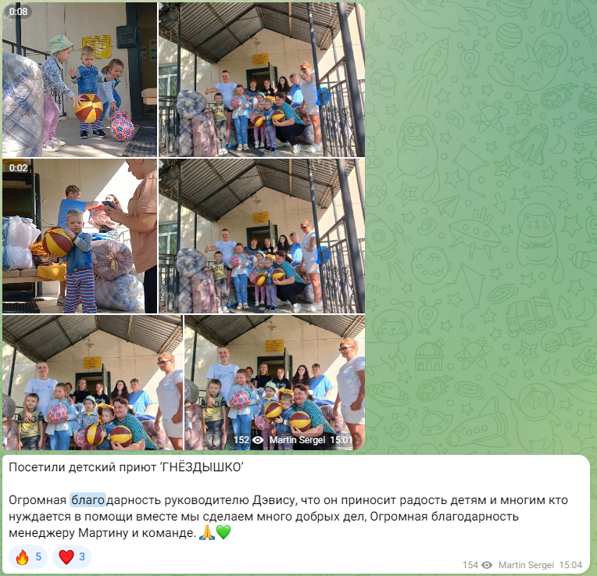

<https://t.me/PRL_PEGASUS/402>

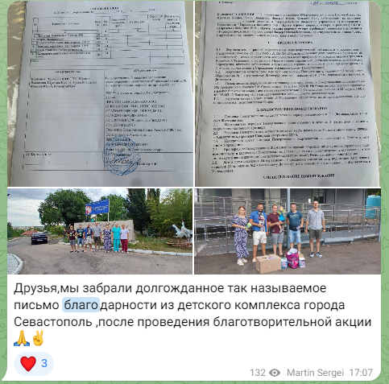

<https://t.me/PRL_PEGASUS/379>

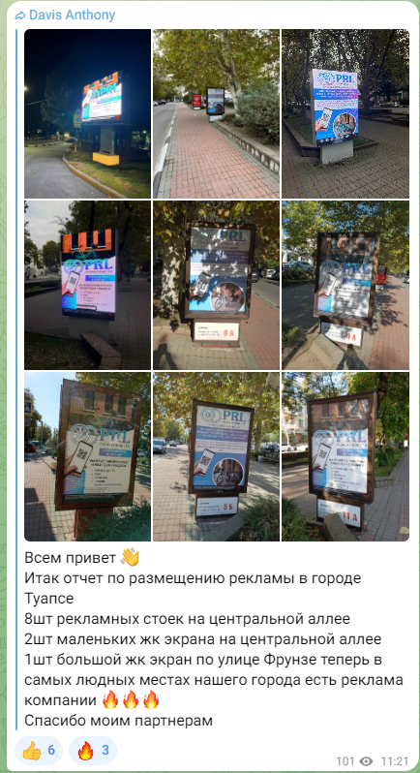

https://t.me/PRL_PEGASUS/2451